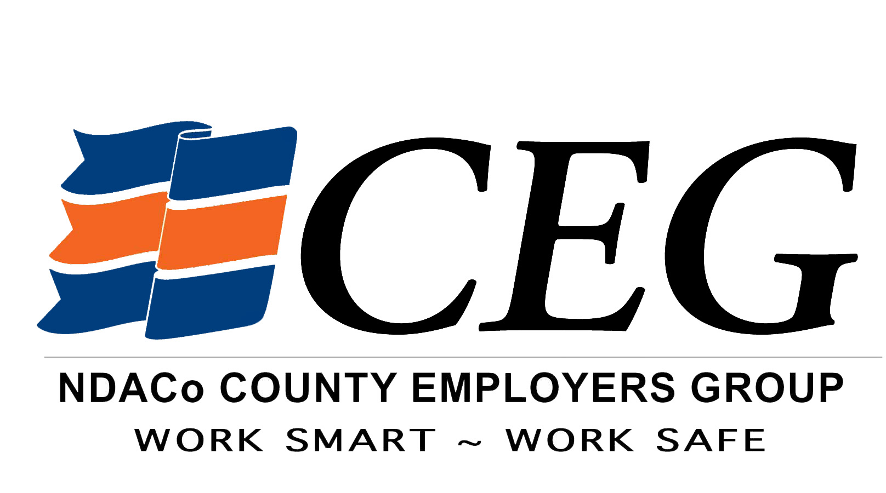
County Employer Group
Reporting Procedures—INCIDENT REPORT
(Updated September 1, 2015)

- WHAT IS AN INCIDENT? Any time an employee has an injury or accident and does not seek immediate medical attention. It is the employee’s responsibility to notify their employer after an incident. It is each county’s responsibility to make sure their employees clearly understand our policy for reporting incidents and work-related injuries.
  - Examples: cuts/lacerations/strains/sprains
- If an employee reports an incident and does not seek immediate medical attention, the employee or Risk Manager must file an online incident report at www.workforcesafety.com (Home>>Employers>>Claims>>If You Have an Injured Employee>>online incident report )in order to qualify for timely reporting. Document in your records any necessary corrective action. On WSI home page click on File an Incident Report (used when medical attention is not being sought). You will be directed to complete the one page incident report. This page contains some required fields that are indicated by a red asterisk (*).
When you are done with the Incident Report filing, you will receive an Incident Report Confirmation page. Be sure to print a copy of this page that shows the submitted date and time in case we need to prove timely filing at a later date. If you have not received a confirmation page, you have not completed the form properly.
NOTE: To qualify for timely reporting with WSI, complete all required fields as best you can. Remember, our goal is to register the claim as soon as possible to ensure timely reporting discounts.
Company Name:
Company Account Number:
Business Name | City | State
 | ND Association Of Counties Inc | Bismarck | ND

- Once you have submitted an Incident Report online, you DO NOT need to FAX a copy to WSI or NDACo. However, make sure you have printed a copy for your records.
If a worker was injured and medical attention is being sought, this is not the correct form to complete online. Please click on File a Claim (Use only if seeking medical treatment).
For any questions contact:
Jennifer Morman, Internal Claims Manager
800-932-8730 (Toll free) or 701-328-7329 (Office)
701-400-9807 (Cell or text)
jmorman@ndaco.org

